Adjective

🟢 What is an Adjective?
# Source: AI Source: Provided by: [Data Path: Persons Table -> ID Column: 1, Name_En Column: Motasem Essam] -> From: [Chatgpt (GPT-4-turbo)] on [7/24/2025]
An adjective is a word that describes or modifies a noun or pronoun. It gives more information about a person, place, thing, or idea.

📘 Definition:
# Source: AI Source: Provided by: [Data Path: Persons Table -> ID Column: 1, Name_En Column: Motasem Essam] -> From: [Chatgpt (GPT-4-turbo)] on [7/24/2025]
An adjective is a word that tells us more about a noun — it describes quality, quantity, size, color, number, or condition.

🧠 Examples of Adjectives:
# Source: AI Source: Provided by: [Data Path: Persons Table -> ID Column: 1, Name_En Column: Motasem Essam] -> From: [Chatgpt (GPT-4-turbo)] on [7/24/2025]
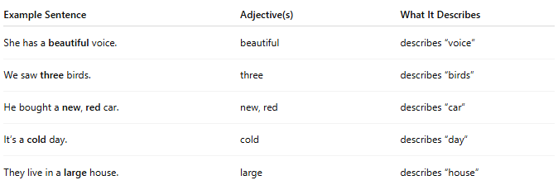
Example Sentence | Adjective(s) | What It Describes
She has a beautiful voice. | beautiful | describes “voice”
We saw three birds. | three | describes “birds”
He bought a new, red car. | new, red | describes “car”
It’s a cold day. | cold | describes “day”
They live in a large house. | large | describes “house”

✳️ Types of Adjectives:
# Source: AI Source: Provided by: [Data Path: Persons Table -> ID Column: 1, Name_En Column: Motasem Essam] -> From: [Chatgpt (GPT-4-turbo)] on [7/24/2025]
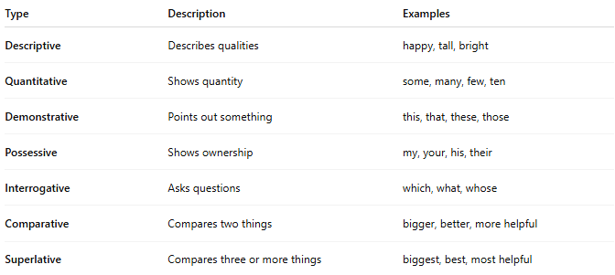
Type | Description | Examples
Descriptive | Describes qualities | happy, tall, bright
Quantitative | Shows quantity | some, many, few, ten
Demonstrative | Points out something | this, that, these, those
Possessive | Shows ownership | my, your, his, their
Interrogative | Asks questions | which, what, whose
Comparative | Compares two things | bigger, better, more helpful
Superlative | Compares three or more things | biggest, best, most helpful

🔄 Placement of Adjectives:
# Source: AI Source: Provided by: [Data Path: Persons Table -> ID Column: 1, Name_En Column: Motasem Essam] -> From: [Chatgpt (GPT-4-turbo)] on [7/24/2025]
- Before the noun:
→ The blue sky.
- After the verb "to be":
→ The sky is blue.

✅ Summary:
# Source: AI Source: Provided by: [Data Path: Persons Table -> ID Column: 1, Name_En Column: Motasem Essam] -> From: [Chatgpt (GPT-4-turbo)] on [7/24/2025]
An adjective tells us what kind, how many, or which one.
It adds detail and color to your language!

